Canny Edge detection based Bengali Number Recognition by Deep Learning

Amit Kishor Das, Iftekharul Mobin, Tasnuva Tarannum
Department of Computer Science and Engineering
BRAC University
Dhaka, Bangladesh
{amitkishordas, iftekhar.mobin, tasnuvaorchy}@gmail.com

Abstract—This research illustrates how to recognize Bengali numbers efficiently. In this paper, we propose neural network model for recognition of Bengali numbers. In this research Bengali number recognition system is trained such a way that can identify Bengali number from diverse handwritten numbers. Firstly, we take each image and detect canny edge which removes the unnecessary noise. After that, we train our system with those images by using Convolutional Neural Network and create a prediction model. Finally, we detect other Bengali numbers with the help of created model and by giving another unique image of a number. Our system can recognize any Bengali number with 90% accuracy and efficiently.
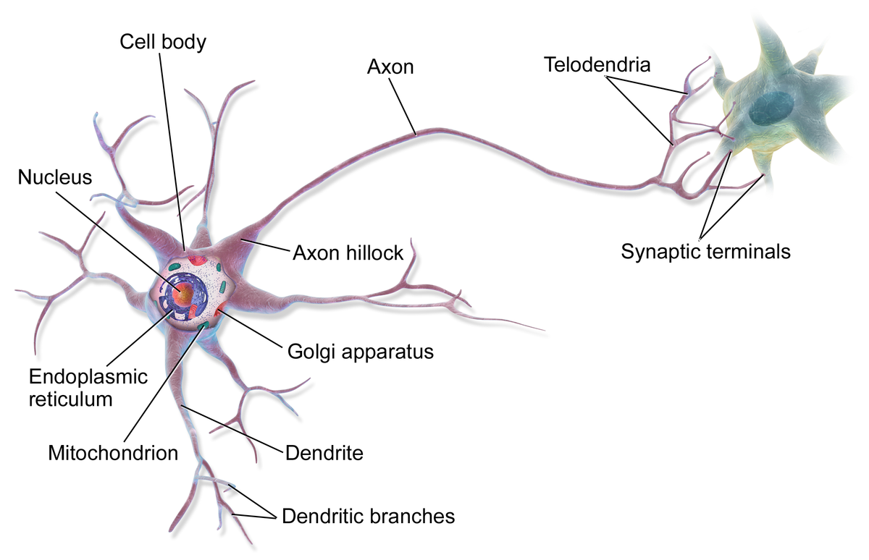
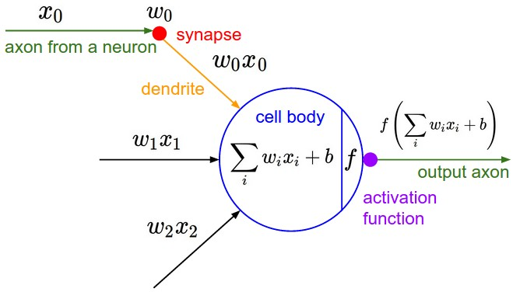
Fig. 1. Illustration of a biological neuron (top) and its mathematical model (bottom)

Keywords—Bengali Number; Recognition; CNN; canny edge

Introduction
Computer Vision has been proven a remarkable entity in modern computer science to recognize objects, patterns. Various applications of this field have been used on a regular basis to identify diverse shapes.
Detecting text or number from an image is a common system. But most of them are for Recognition of English language or other language. But our research will help a machine to recognize Bengali Numbers correctly. For this, machine learning with deep learning approach is required with the help of Convolutional Neural Network [1]. The world is getting machine dependent in this modern time. So, it would be very helpful if a machine can recognize Bengali text or numbers from an image. To detect object with good accuracy we have introduced deep learning method called Convolutional Neural Network along with Canny Edge detection to recognize Bengali numbers with less errors[2][ 3]. Further, it will take less time and be more efficient than the previous works for Number detection. The primary aim of this research is to apply deep learning approach for image recognition with maximum accuracy. There has been a lot of work done in this field using various methods which all have their shortcomings. We have worked on Canny Edge detection [3] to detect edges of every image. Besides, for image processing and recognition, deep learning can easily be applied with great success. We study different kind of deep neural networks algorithm and train the procedure with the art of Convolutional Neural Network [4].

The purpose of CNN

Convolutional Neural Network
By comparing with real time neuron from biological perception, a neural network is a structure of consistent artificial “neurons” which is supposed to exchange message

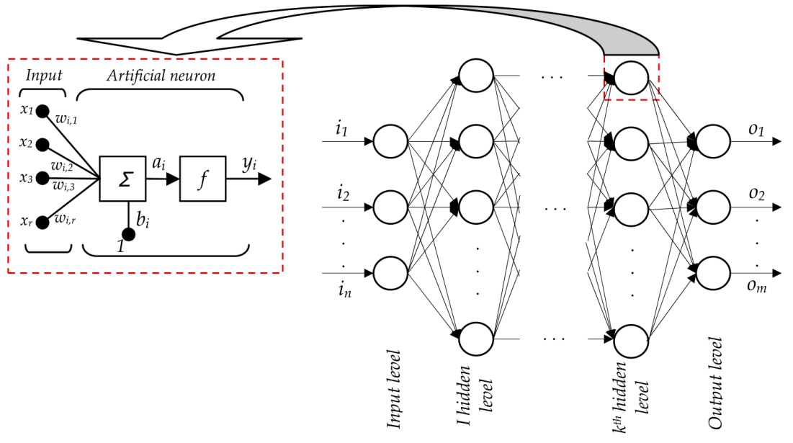

among each other [5]. The connections are processed by numeric weights which enable to respond without errors when it is examined with certain image or pattern to recognize. The neurons are of multiple layers. Every layer consists of many neurons which are responsive to various combinations of input from the past layers [5].
Training is measured by some label of trained dataset. By using general-purpose methods, training uses to iteratively find out the weights for transitional and very last feature of neurons. Figure 2 shows the training process at a block level [6].
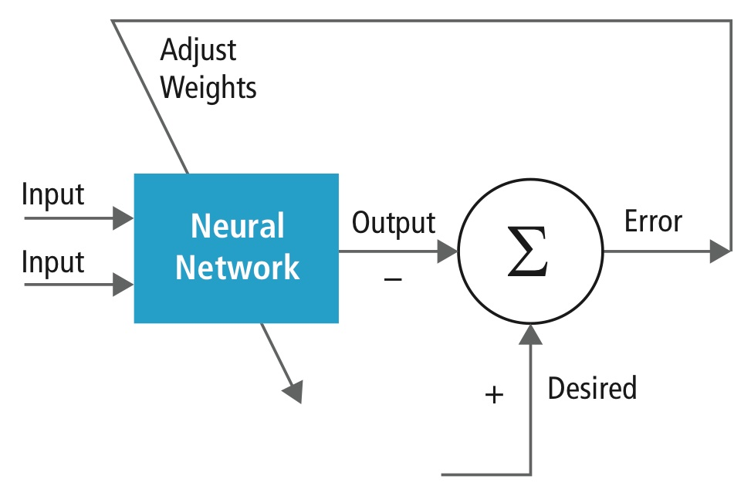
Fig. 2. Training of neural network [5].
The proposed model has opened the door of new technique to recognize images. After conducting comparison with our proposition with others models, we have achieved a promising result.

Sysyem Model
In our proposed model, at first our initial task was detecting canny edge of every image. After using canny edge detection we have come up with only the structure of every digit then we used those images as training set for CNN in which 80% of data set is training set and 20% of data is used as test set [7]. This time, we train the model according to CNN convention and again make a classifier model which can accurately determine the unique digit.
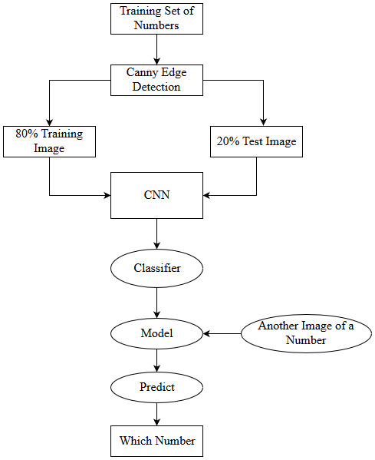

Fig. 4. Proposed Model of Digit Recognition

Canny Edge Detection
The purpose of edge detection in general is to significantly reduce the amount of data in an image, while preserving the structural properties to be used for further image processing. So we used Canny Edge detection to remove all the unnecessary data or noise. After Canny Edge detection we get nothing but the structure of every digit.


Fig. 3. Canny Edge Detection

Creating Trainning set
After we have detection of Canny Edge, we proceed to develop further tasks by starting with about 1547 images of all ten Bengali digits. About 1237 photos of 10 Bengali digits starting from zero to nine are taken for creating training set.

Creating test set
To work our model of Convolutional Neural Network, a test set is also required for the procedure to be done. For this purpose we again have taken 310 images of all 10 digits. This test set will help to evaluate other images by comparing with it.




Fig. 5. Images of Training Set (top) and Test Set (bottom)

Creating CNN Classifier
After 3 steps of layering process of Convolution we can transform low level features to high level features of each image then we have headed for pooling layer method [8]. In the process of creating CNN Classifier the first step is Convolution. In Convolution part it extracts binary features of every image. Next step is pooling layer. The pooling layer decreases the resolution of the features and makes the features more robust against noise and alteration. After pooling layer, the images are shifted to flattening layer where all layers merge into single layer containing the most prominent features from 3X3 pixels of images. [9][10].
After creating the flattening layer, lastly, we proceed to last layer of CNN which is Fully-Connected layer. These layers summing up the weighting of the earlier layer of features that indicates the accurate mix of ingredients to verify a fixed target output result. In a fully connected layer, all the elements of all the features of the earlier layer are used for calculation of each element of each output feature [5].

Analysis And Result
In this work we have collected images by ourselves as primary raw data and also have used the source code of author [10] which is later modified by the requirement of our work. Our model has achieved 84% accuracy to recognize Bengali digits.
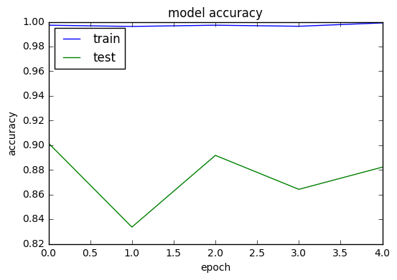
Fig. 6. Graph of our Model’s Accuracy
We can see that, while we have been training our test dataset, we could see the fluctuation of the total accuracy of our model to recognize the precise object. At the end point when our procedure has completed, the accuracy gradually build up and ended with 84% accuracy which is very good result in image recognition field.

We could also determine the net loss of our work to predict the actual accuracy and fineness of our model. At first, the percentage of loss good while we are training our model but later it has started decreasing steadily and ended at almost 77% which indicates that loss is less with much very good consistency than the expected prediction.
This certainly indicates that our model functions with good precision and less errors.
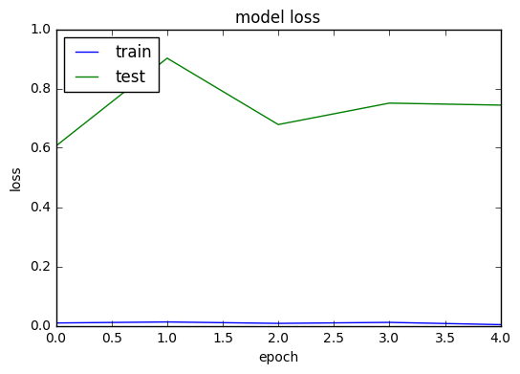
Fig. 7. Graph of our Model’s Loss

Here Accuracy,
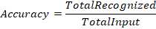

- Accuracy of True detection
Round | Number of Images | Detection |  | Accuracy of True Detection | Average Accuracy
Round | Number of Images | True | False | Accuracy of True Detection | Average Accuracy
1 | 20 | 16 | 4 | 80%
2 | 35 | 30 | 5 | 85% | 83%
3 | 50 | 42 | 8 | 84%

We can take some images and then detect Canny Edge and after that when we implement CNN model on the test set, we observe a good accuracy with average 80% or more than 80% in every possible test set that we have created. We can determine the true detection with very good precision and then again by averaging all the accuracy we can certainly determine about 83% exactness of our model work.

Conclusion And Future Plan
In our paper, we have been worked on image recognition by deep learning with the help of Canny Edge Detection and also as a part of deep learning. Convolutional Neural Network have been applied by us into it. Our model provides higher accuracy for detecting Bengali characters.
Further, if we test the model with blurry or distortion picture then it cannot determine the targeted object of that specific picture. This drawback could also lead us to our future work to make our model more robust and more significant to recognize precise objects from the image. These issues will be looked forward to solve in proper research.

References

- Deshpande, A. (n.d.). The 9 Deep Learning Papers You Need To Know About (Understanding CNNs Part3. Retrieved August 03, 2017, from https://adeshpande3.github.io/adeshpande3.github.io/The-9-Deep-Learning-Papers-You-Need-To-Know-About.html
- Geitgey, A. (2016, June 13). Machine Learning is Fun! Part 3: Deep Learning and Convolutional Neural Networks. Retrieved August 03, 2017, from https://medium.com/@ageitgey/machine-learning-is-fun-part-3-deep-learning-and-convolutional-neural-networks-f40359318721
- Green, B. (2002). Canny edge detection tutorial. Internet: http://www. scribd. com/doc/40036113/Canny-Edge-Detection-Tutorial..
- Simard, P., Steinkraus, D., & Platt, J. (n.d.). Best practices for convolutional neural networks applied to visual document analysis. Seventh International Conference on Document Analysis and Recognition, 2003. Proceedings. doi:10.1109/icdar.2003.1227801
- Hijazi, S., Kumar, R., & Rowen, C. (2015). Using convolutional neural networks for image recognition. Tech. Rep., 2015.[Online]. Available: http://ip. cadence. com/uploads/901/cnn-wp-pdf.
- Wu, R., Yan, S., Shan, Y., Dang, Q., & Sun, G. (2015, July 06). Deep Image: Scaling up Image Recognition. Retrieved August 03, 2017, from https://arxiv.org/abs/1501.02876
- LeCun, Y., &Bengio, Y. (1995). Convolutional networks for images, speech, and time series. The handbook of brain theory and neural networks, 3361(10), 1995.
- Gu, J., Wang, Z., Kuen, J., Ma, L., Shahroudy, A., Shuai, B., ...& Wang, G. (2015). Recent advances in convolutional neural networks. arXiv preprint arXiv:1512.07108.
- Lu, Y. (2016, December 03). Food Image Recognition by Using Convolutional Neural Networks (CNNs). Retrieved August 03, 2017, from https://arxiv.org/abs/1612.00983
- Object Recognition with Convolutional Neural Networks in the Keras Deep Learning Library. (2017, March 30). Retrieved August 03, 2017, from http://machinelearningmastery.com/object-recognition-convolutional-neural-networks-keras-deep-learning-library/

